St. Joseph’s Anglo-Chinese School
Form 6 English Language
Paper 4 Speaking – Exam Practice (DSE 2023 Set 2.3)
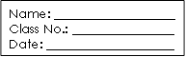
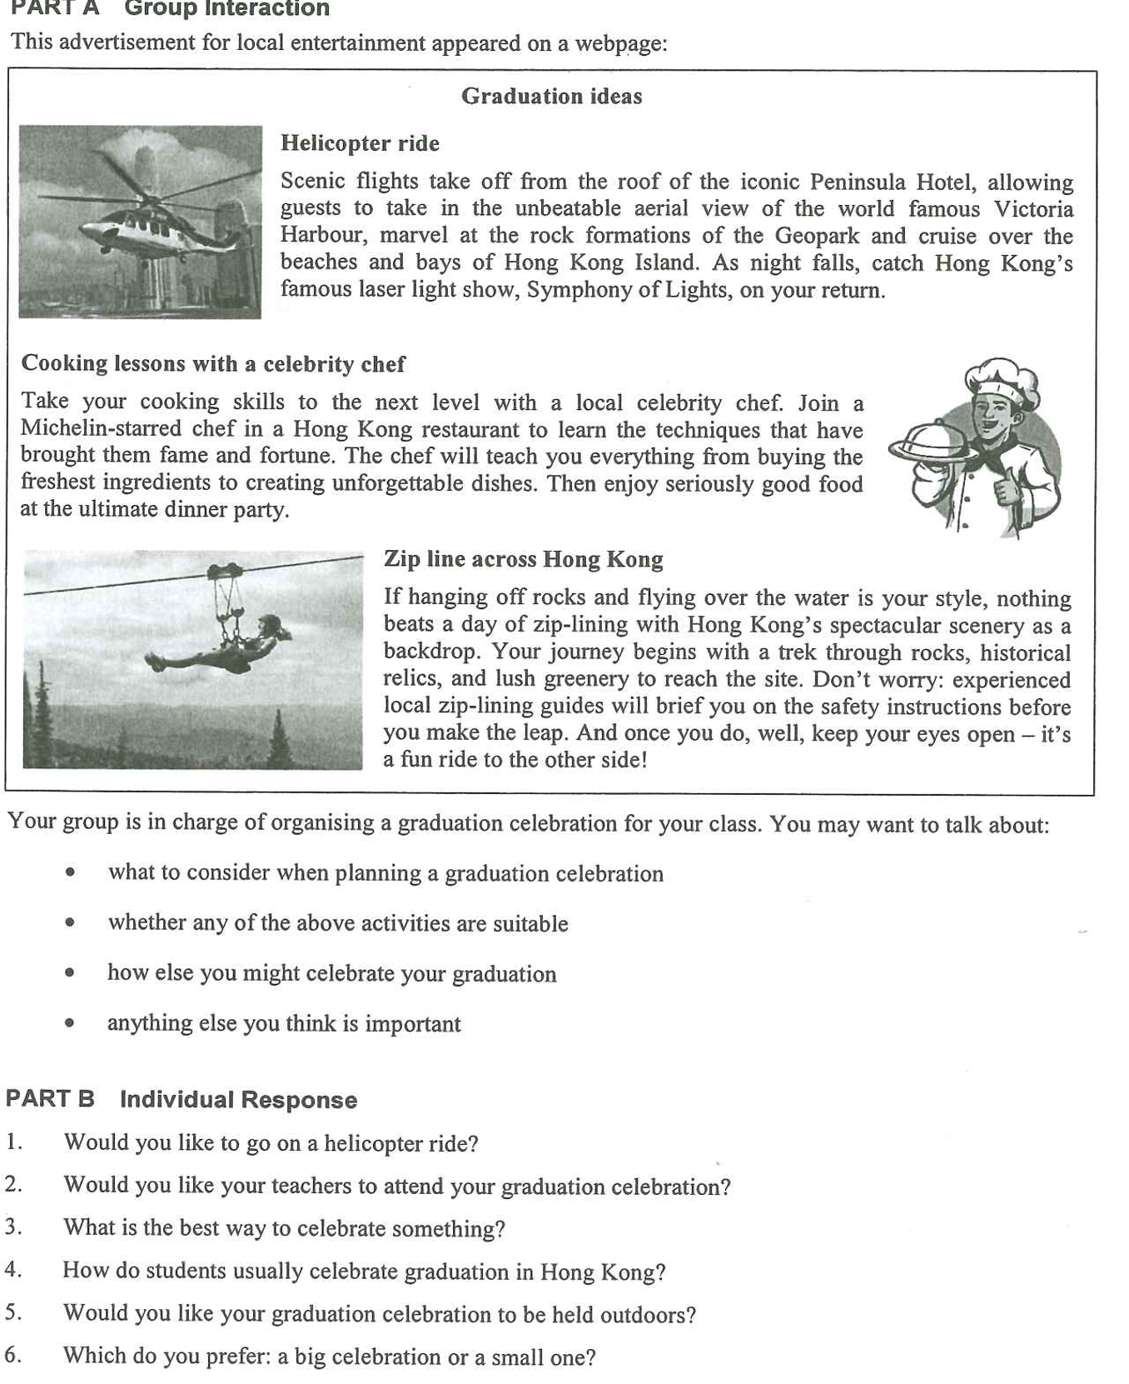
Note Grid – Your Notes for the Discussion
1. what to consider when planning a graduation celebration | 2. whether any of the above activities are suitable
3. how else you might celebrate your graduation | 4. anything else you think is important

Note Grid – Your Notes for Part B Individual Response Questions
Question: ___________ | Question: _____________

