St. Joseph’s Anglo-Chinese School
Form 6 English Language
Paper 4 Speaking – Exam Practice (DSE 2023 Set 2.3)

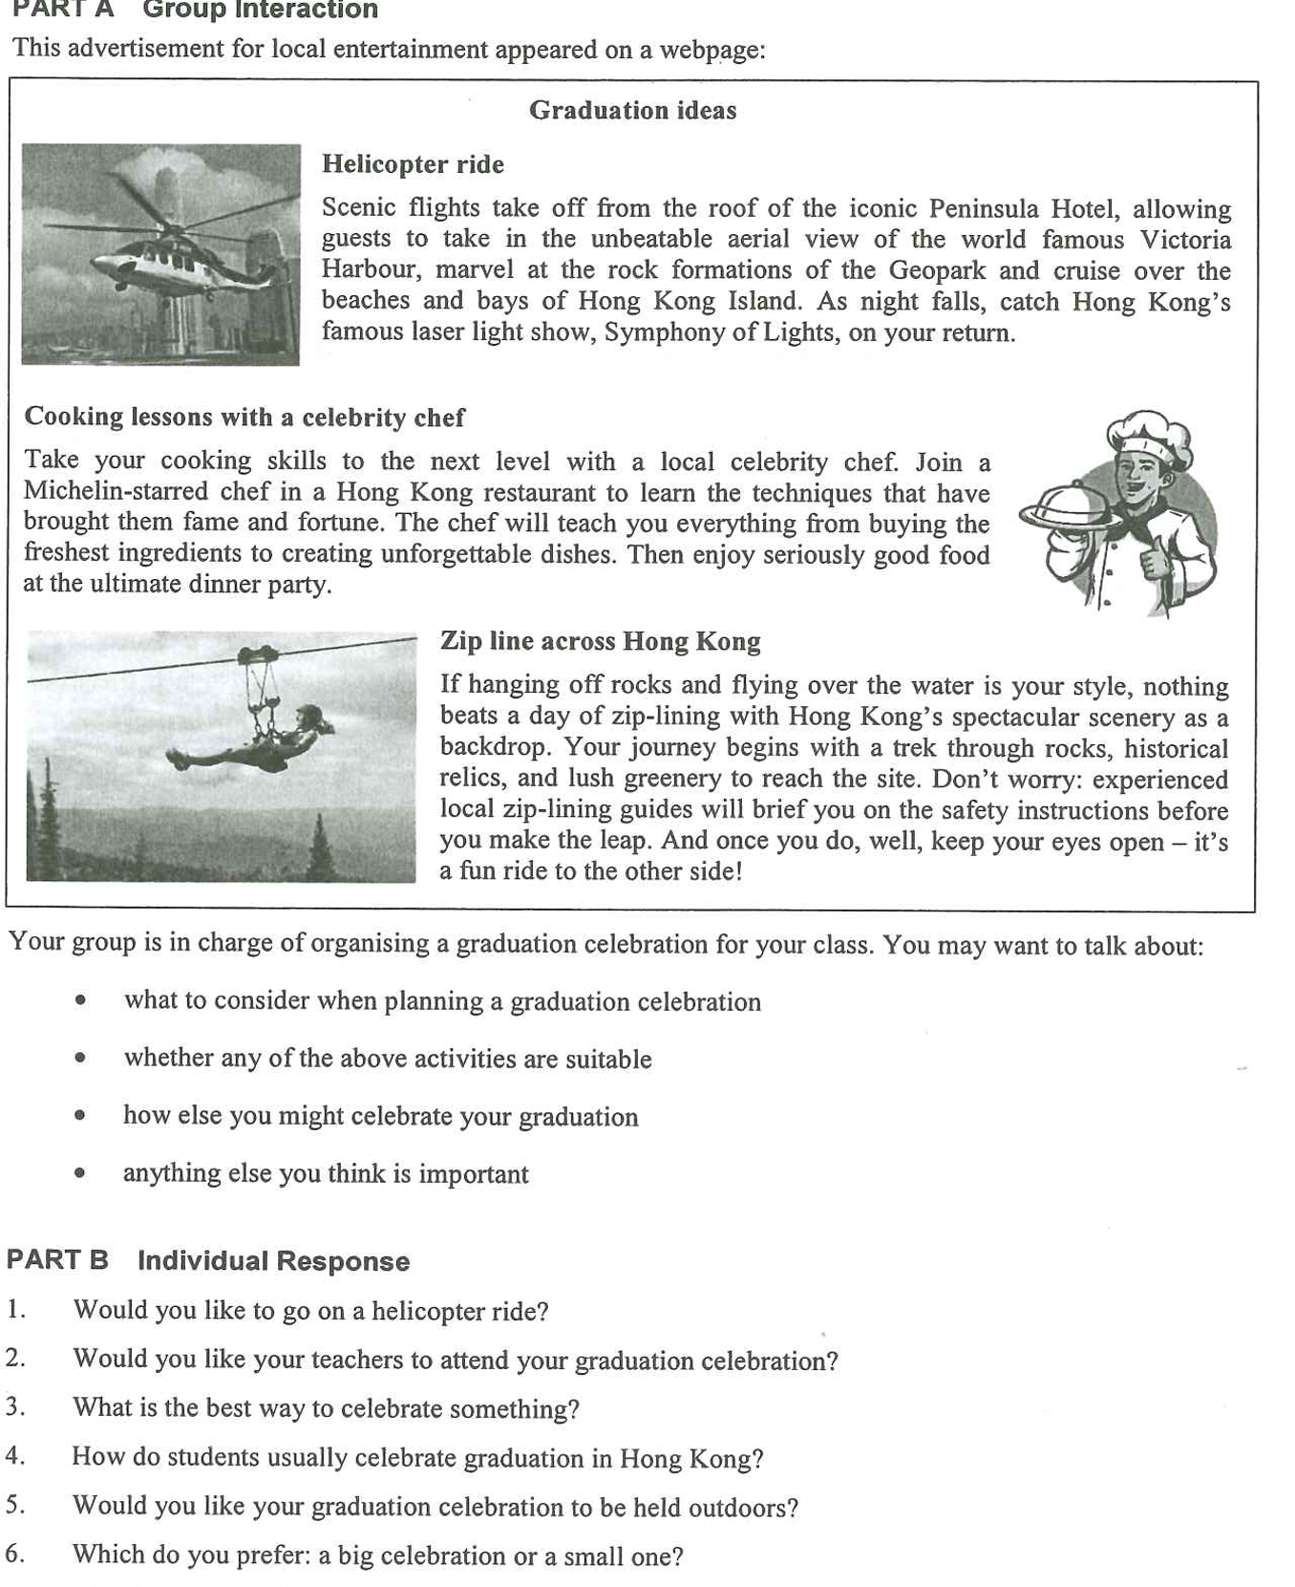

Warm-up – Two Easier Part B Questions (6 minutes, in pairs)
Both partners answer the same question. Push for a time, a reason and one detail — not a one-word answer. This is where you hear their Level 3 baseline.
Question 1 | Would you like to go on a helicopter ride? | What to listen for
Model answer | I would try it once — a ten-minute flight over Victoria Harbour at night, with the Symphony of Lights below us. But a seat costs more than the whole class dinner, so I would not pay for it myself. | A clear yes or no, one detail taken from the advert (the Peninsula, the harbour, the light show) and a view on the price
Question 2 | Would you like your teachers to attend your graduation celebration?
Model answer | I would invite our form teacher, because she has known us since Form 1, but not the whole staff — when teachers are in the room we behave differently and the party stops being ours. | Whether they can hold both sides — respect for the teachers and the freedom to celebrate — and still give a reason

▸ Upgrade opportunity — take what they say and lift it
“What I usually say” | Upgrade (useful for Part A and Part B) | Where it pays off
“It will be fun.” | It will be a once-in-a-lifetime experience for the class. | Warm-up Q1; Part A bullet 2
“We have to plan everything.” | Someone has to take charge of the arrangements and the budget. | Part A bullet 1; Part B Q7
“It costs too much.” | The cost per head would put some classmates off. | Part A bullet 2; Part B Q8
“It is a goodbye party.” | It gives us a proper send-off — a milestone worth marking. | Part A bullet 3; Part B Q8

Part A – The Discussion Task (10 min preparation, 8 min discussion)
Your group is in charge of organising a graduation celebration for your class. You may want to talk about: what to consider when planning a graduation celebration; whether any of the above activities are suitable; how else you might celebrate your graduation; anything else you think is important.
▸ Say it another way — synonyms to replace the question’s own wording
Students who recycle the paper’s words score lower than students who paraphrase. Put these on the board and ban the left-hand column.
The question says… | Say instead | Model sentence
what to consider | the key factors · what has to be settled first · the practical side | The first thing to settle is the budget and how it is shared.
planning | putting the event together · taking charge of the arrangements · the logistics | Taking charge of the arrangements is easier with a small committee.
a graduation celebration | our farewell event · the end-of-school send-off · the final class party | Our farewell event should include everyone, not just close friends.
whether … are suitable | whether … fit the occasion · whether … are worth the money · whether … suit the whole class | A zip line may not suit the whole class — some of us are afraid of heights.
how else you might celebrate | other ways to mark the occasion · alternative plans · what else we could do | Other ways to mark the occasion include a dinner with a photo slideshow.
anything else you think is important | one thing often overlooked · what also matters here · a further consideration | One thing often overlooked is the photos and videos that keep the day alive.

Ideas for the Note Grid – Noun Phrases per Question, with a Model Example (the same sets appear on the deck: Q1–Q3, then Part B Q7–Q8)
Give the noun phrase first (it is what they write in the grid), then the model example (it is what they say). The points in each set are deliberately different in kind, so a group cannot make the same point twice. Sets 3, 7 and 8 are built in two halves — YES: … and NO: … — so on a two-sided question the group always has both sides ready; in Part B that lets a student concede a line and then commit.
1. what to consider when planning a graduation celebration
• a budget the whole class can afford | e.g. If the target is HK$300 per head, nobody has to stay home because they cannot pay — that is what keeps it a class event.
• activities everyone can join | e.g. A zip line looks brilliant on paper, but the shy ones and the tallest also have to be able to take part.
• a date that fits the post-exam calendar | e.g. Plan for the weeks after the DSE papers, before everyone scatters to summer jobs and interviews.

2. whether any of the above activities are suitable
• YES: a real once-in-a-lifetime treat | e.g. Nobody hires a helicopter or a Michelin chef twice — the class will talk about it for years.
• YES: shared memories and photos for the yearbook | e.g. A cooking class or a zip line gives everyone something to laugh about in the same photo.
• NO: too pricey for a whole class | e.g. A helicopter seat costs more than the whole class dinner, so half the class would opt out.
• NO: safety and fitness limits | e.g. Zip-lining needs a health declaration and a briefing, and not every eighteen-year-old can join.

3. how else you might celebrate your graduation
• a farewell dinner with a slideshow | e.g. Book a restaurant, play five years of photos and ask two people to speak.
• a school-hall party with music and games | e.g. The school hall is free, so the whole class can come for a few hundred dollars.
• a low-cost outing or camp | e.g. A barbecue, a hike or an overnight camp costs a fraction of a helicopter ride and includes everyone.
Note: the fourth bullet (anything else you think is important) has no slide — it is the group’s open floor. If they stall, prompt with the photos and videos that keep the day alive, who should be invited (teachers, families, other classes) or how the class will stay in touch afterwards.

Part B – Individual Response: Questions 7 and 8 (1 minute each)
Q7. Would you like to be on the school graduation organising committee?
4 noun-phrase ideas (2 YES · 2 NO) | Model example
• YES: a chance to shape the event | I would rather decide the programme than complain about it afterwards.
• YES: useful leadership and budgeting experience | It is something real to put in my university application — not just a club membership.
• NO: the work collides with my DSE revision | The committee meets every week, and my revision already fills every evening.
• NO: the blame when something goes wrong | Whoever books the restaurant takes the complaints about the food and the price.

▸ Upgrade opportunity for Q7
“What I usually say” | Upgrade | Why it scores
“I want to help plan it.” | I would like to take charge of the arrangements. | Names the role precisely
“It looks good on my record.” | It would strengthen my university application. | A formal, specific reason
“It is too much work.” | The workload would clash with my revision schedule. | Names the cost precisely
Q8. Is a graduation celebration meaningful to you?
2 noun-phrase ideas (YES · NO) | Model example
• YES: a proper send-off for six years | Six years of classmates deserve more than a message in the group chat.
• NO: the friendships matter more than the party | A dinner does not make us closer — the people I will still text in five years are already clear.

▸ Upgrade opportunity for Q8
“What I usually say” | Upgrade | Why it scores
“It is just a party.” | It is a milestone — the end of one stage and the start of the next. | Reframes the event
“I want to remember my class.” | It gives us a shared memory to look back on. | Names the value, not the event
“I don’t need a ceremony.” | The celebration means less to me than the friendships it marks. | Concedes, then commits

