St. Joseph’s Anglo-Chinese School
Form 6 English Language
Paper 4 Speaking – Exam Practice (DSE 2023 Set 4.3)
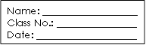
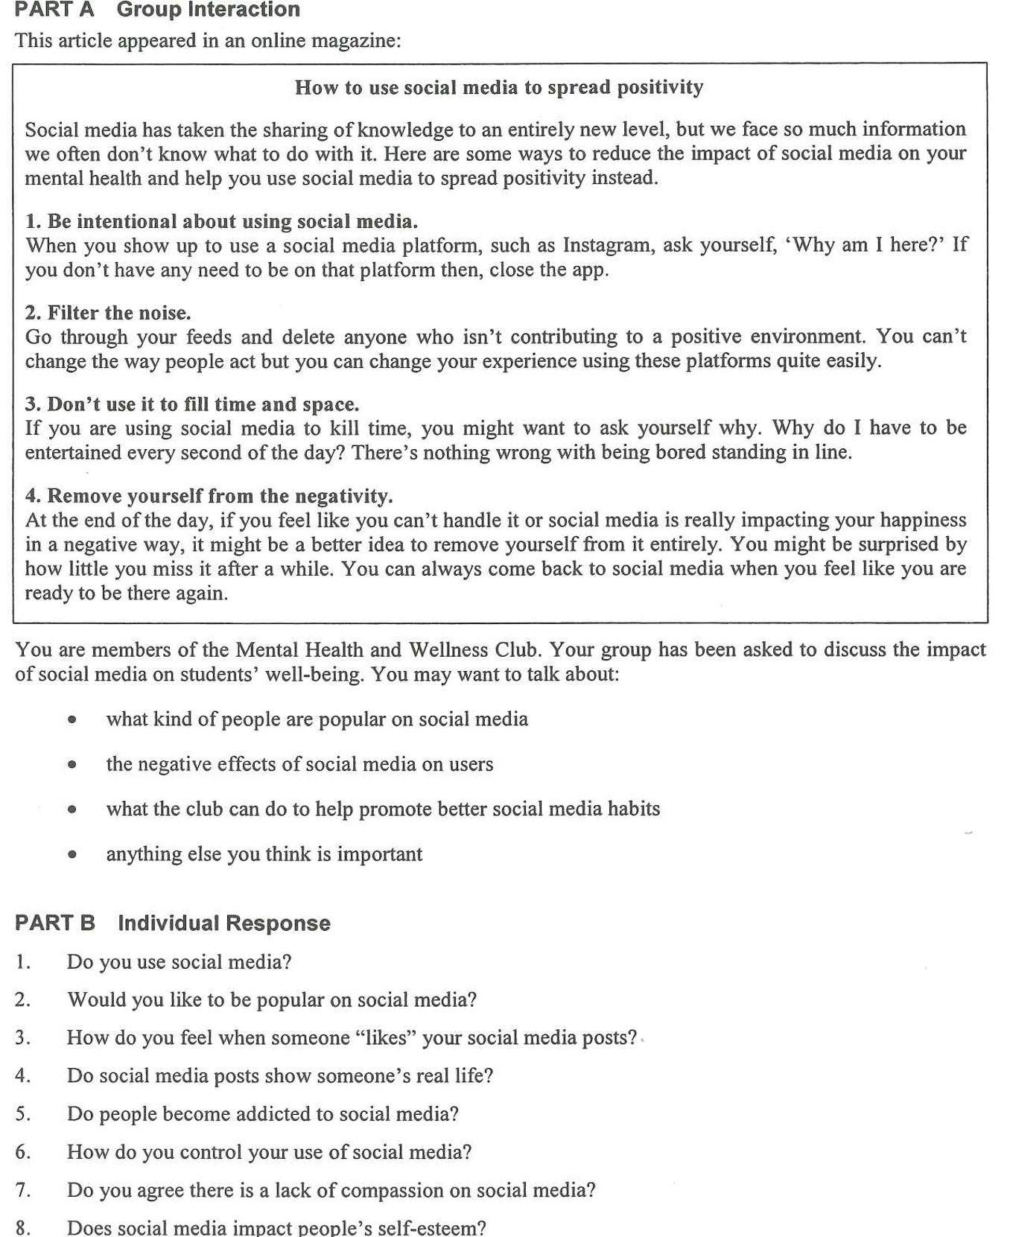
Note Grid – Your Notes for the Discussion
1. what kind of people are popular on social media | 2. the negative effects of social media on users
3. what the club can do to help promote better social media habits | 4. anything else you think is important

Note Grid – Your Notes for Part B Individual Response Questions
Question: ___________ | Question: _____________

