St. Joseph’s Anglo-Chinese School
Form 6 English Language
Paper 4 Speaking – Exam Practice (DSE 2023 Set 4.3)
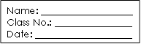
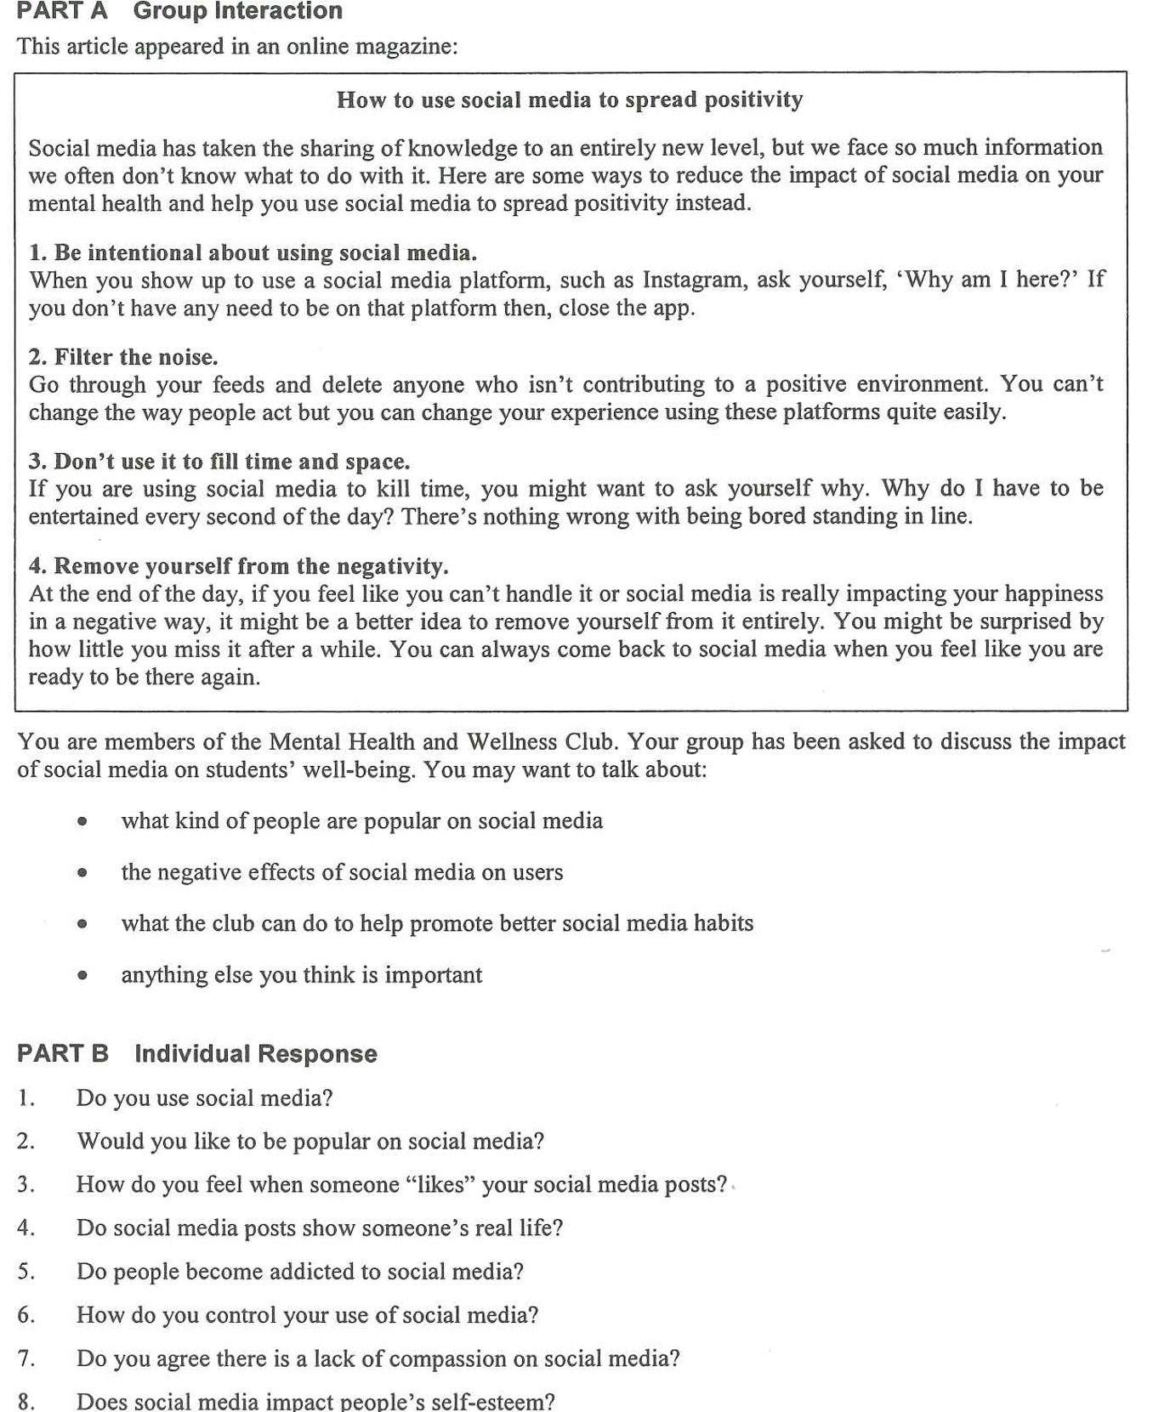

Warm-up – Two Easier Part B Questions (6 minutes, in pairs)
Both partners answer the same question. Push for a time, a reason and one detail — not a one-word answer. This is where you hear their Level 3 baseline.
Question 1 | Do you use social media? | What to listen for
Model answer | Every day — Instagram and WhatsApp, mainly to keep in touch with my class group — but I have turned off notifications because I was checking my phone every ten minutes. | How much, which platforms, and whether they show any awareness of their own habits
Question 2 | Would you like to be popular on social media?
Model answer | Part of me would — a hundred likes feels good — but the accounts with the biggest followings post the most extreme things, and I would not want to live like that. | Whether they can name both the pull (attention, approval) and the cost (pressure, a fake image)

▸ Upgrade opportunity — take what they say and lift it
“What I usually say” | Upgrade (useful for Part A and Part B) | Where it pays off
“I use my phone too much.” | My screen time is out of control — I check my feed out of habit. | Warm-up Q1; Part B Q6
“I care about likes.” | I am chasing the approval of people I barely know. | Warm-up Q2; Part B Q3
“People are mean online.” | There is a real lack of compassion in the comment sections. | Part A bullet 2; Part B Q7
“It makes people feel bad.” | Constant comparison damages users’ self-esteem. | Part A bullet 2; Part B Q8

Part A – The Discussion Task (10 min preparation, 8 min discussion)
You are members of the Mental Health and Wellness Club. Your group has been asked to discuss the impact of social media on students’ well-being. You may want to talk about: what kind of people are popular on social media; the negative effects of social media on users; what the club can do to help promote better social media habits; anything else you think is important.
▸ Say it another way — synonyms to replace the question’s own wording
Students who recycle the paper’s words score lower than students who paraphrase. Put these on the board and ban the left-hand column.
The question says… | Say instead | Model sentence
the impact of social media | the effect it has · the influence it has on us · what it does to us | The effect on a Form 6 student’s sleep is easy to see.
students’ well-being | students’ mental health · how students feel about themselves · students’ state of mind | The club exists to protect students’ mental health.
what kind of people are popular | who gets the followers · which accounts attract an audience · what makes an account stand out | Accounts that post extreme opinions get the followers.
the negative effects | the downsides · the damage it can do · the price users pay | The downsides are clearest in the comments section.
to help promote better habits | to encourage healthier habits · to nudge students towards … · to raise awareness of … | The club could raise awareness of screen time.
anything else you think is important | one thing often overlooked · what also matters here · a further consideration | One thing often overlooked is what the platforms earn from our attention.

Ideas for the Note Grid – Noun Phrases per Question, with a Model Example (the same sets appear on the deck: Q1–Q3, then Part B Q7–Q8)
Give the noun phrase first (it is what they write in the grid), then the model example (it is what they say). The points in each set are deliberately different in kind, so a group cannot make the same point twice. Sets 3, 7 and 8 are built in two halves — YES: … and NO: … — so on a two-sided question the group always has both sides ready; in Part B that lets a student concede a line and then commit.
1. what kind of people are popular on social media
• accounts with an extreme opinion | e.g. The posts that travel furthest are the angriest ones — outrage gets shared.
• the perfect-looking lifestyle | e.g. Travel, clothes and study notes arranged so that nobody sees the mess behind the photo.
• the fastest, shortest content | e.g. Fifteen-second clips beat anything longer — the algorithm rewards them.

2. the negative effects of social media on users
• anxiety from constant comparison | e.g. You compare your ordinary Tuesday with everyone else’s best day.
• lost concentration and lost sleep | e.g. One more scroll at midnight costs an hour of sleep and the next day’s focus.
• a lack of compassion in the comments | e.g. Anonymous accounts post insults they would never say to a face.
• a false picture of other people’s lives | e.g. Followers see a highlight reel and believe it is the whole story.

3. what the club can do to help promote better social media habits
• a no-phone hour or a screen-time challenge | e.g. Ask the whole school to log their screen time for a week and compare it with their sleep.
• a peer-led workshop on spotting fake lives | e.g. Older students explain how a feed is edited before it is posted.
• a quiet space and someone to talk to | e.g. A lunchtime room where students can say “the app is making me anxious” without being judged.
Note: the fourth bullet (anything else you think is important) has no slide — it is the group’s open floor. If they stall, prompt with what the platforms earn from our attention, the difference between a follower and a friend, or how a class WhatsApp group can be kind or cruel.

Part B – Individual Response: Questions 7 and 8 (1 minute each)
Q7. Do you agree there is a lack of compassion on social media?
4 noun-phrase ideas (2 AGREE · 2 DISAGREE) | Model example
• AGREE: the comment sections make it plain | Under every news post, the cruellest comment sits with the most likes.
• AGREE: anonymity removes the consequences | Nobody says those things to a person’s face.
• DISAGREE: every crisis brings an outpouring of support | When a student went missing last year, strangers shared the post thousands of times.
• DISAGREE: compassion just looks different online | A short “are you okay?” message can reach someone at 2 a.m., when nobody can visit.

▸ Upgrade opportunity for Q7
“What I usually say” | Upgrade | Why it scores
“People are horrible online.” | There is a real lack of compassion in the comment sections. | Names the problem precisely
“They would never say it to my face.” | Anonymity removes the consequences of what they write. | Explains the cause
“Social media can be kind too.” | Compassion online simply looks different — a message can arrive instantly. | Concedes, then counters
Q8. Does social media impact people’s self-esteem?
2 noun-phrase ideas (YES · NO) | Model example
• YES: comparison is built into the app | The app counts your likes and shows you who got more.
• NO: the impact depends on how you use it | Curating your feed turns a harmful app into a useful one — the article’s own advice.

▸ Upgrade opportunity for Q8
“What I usually say” | Upgrade | Why it scores
“It makes people feel bad.” | Constant comparison damages users’ self-esteem. | Formal, precise vocabulary
“Likes make me happy.” | A like is instant approval — and it is addictive. | Names the pull honestly
“It depends on the person.” | The impact depends on how intentionally you use the platform. | Uses the article’s own idea

