St. Joseph’s Anglo-Chinese School
Form 6 English Language
Paper 4 Speaking – Exam Practice (DSE 2023 Set 7.1)
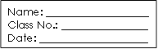
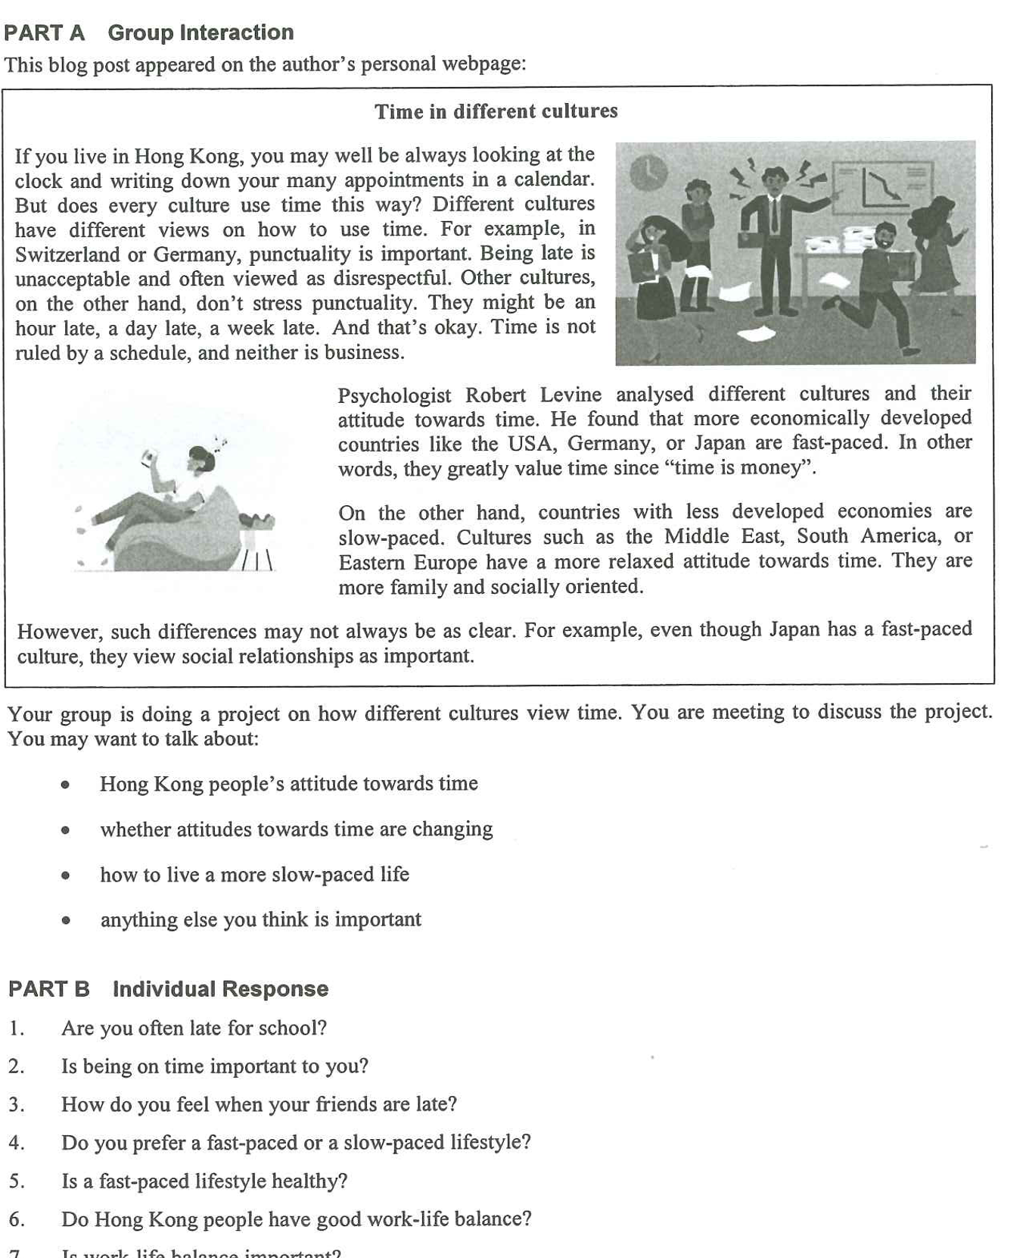
Note Grid – Your Notes for the Discussion
1. Hong Kong people’s attitude towards time | 2. whether attitudes towards time are changing
3. how to live a more slow-paced life | 4. anything else you think is important

Note Grid – Your Notes for Part B Individual Response Questions
Question: ___________ | Question: _____________

