St. Joseph’s Anglo-Chinese School
Form 6 English Language
Paper 4 Speaking – Exam Practice (DSE 2023 Set 7.1)
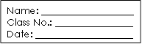
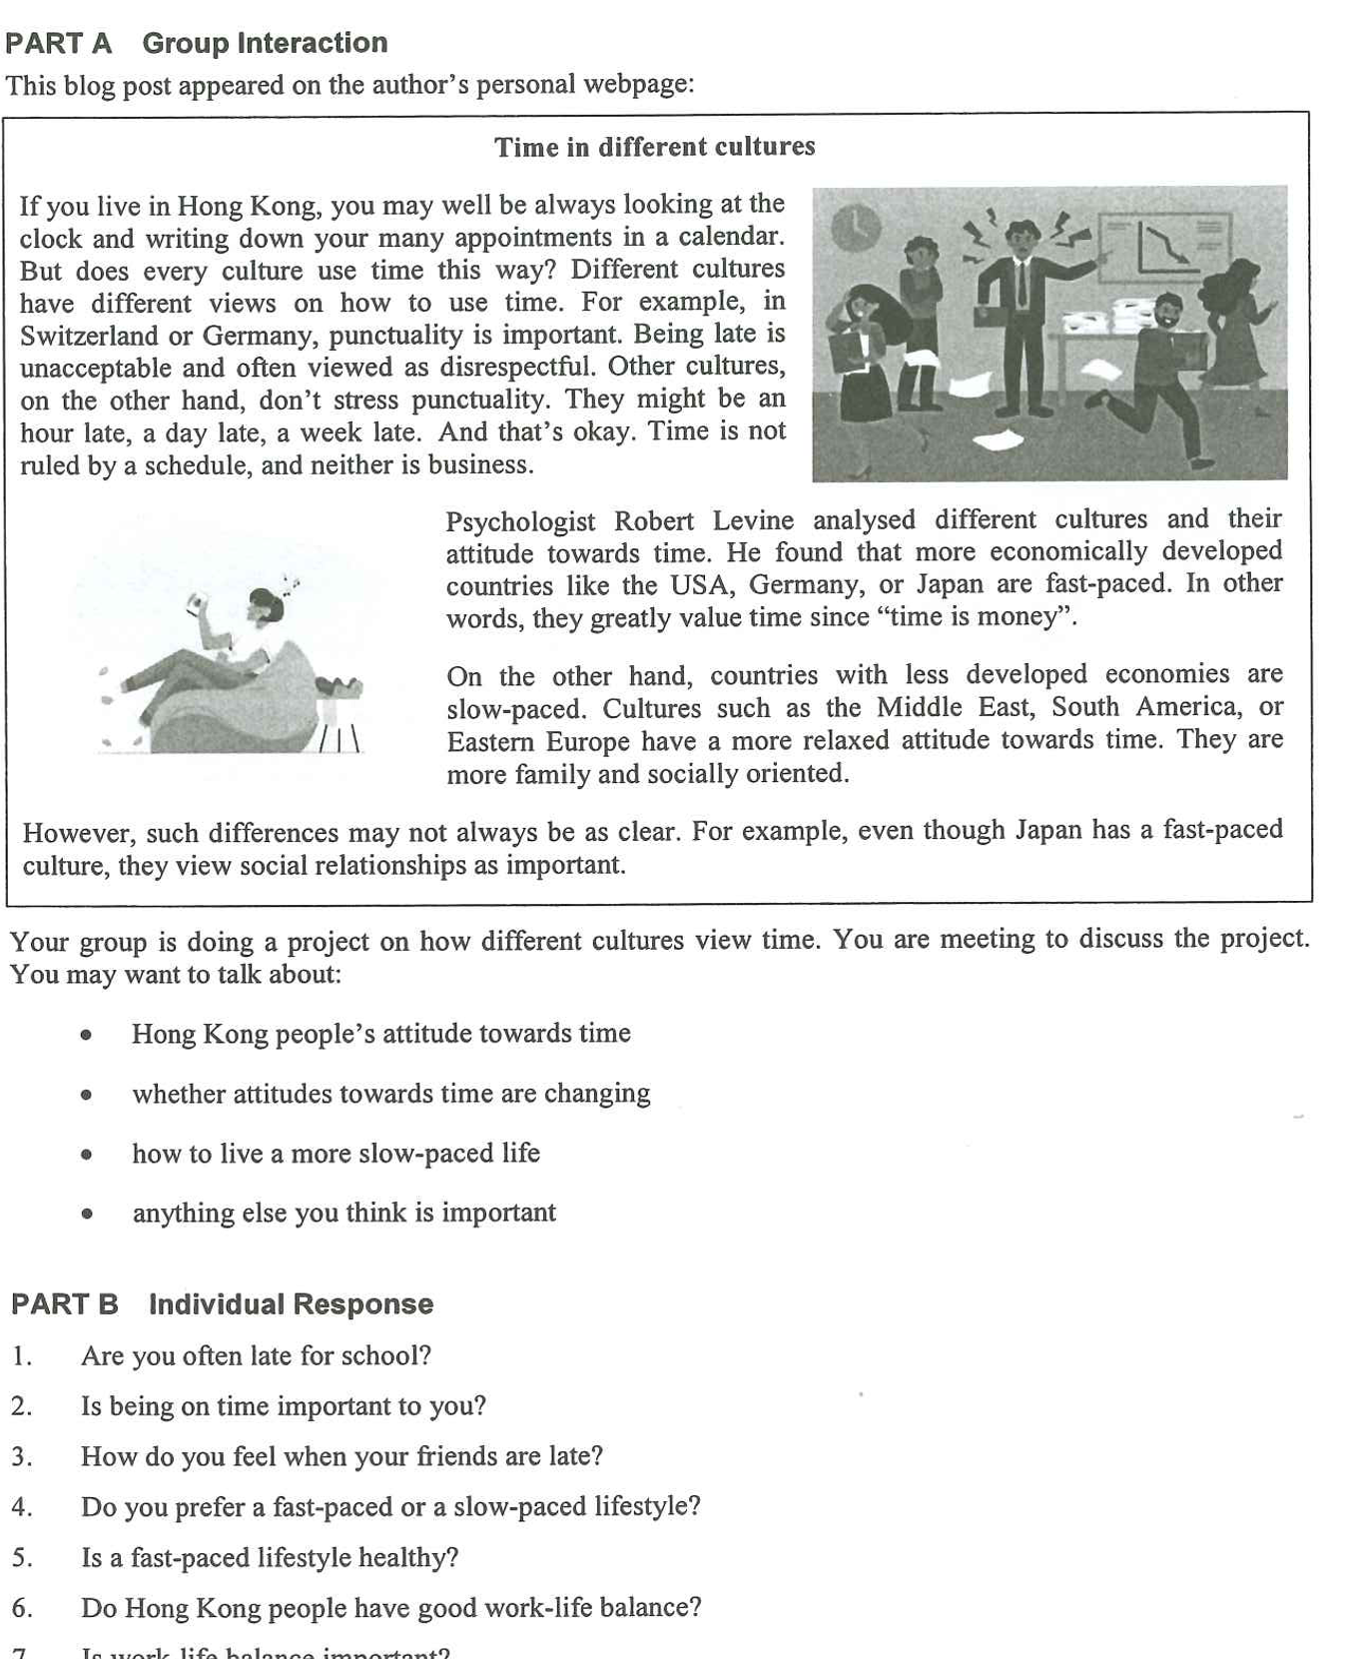

Warm-up – Two Easier Part B Questions (6 minutes, in pairs)
Both partners answer the same question. Push for a time, a reason and one detail — not a one-word answer. This is where you hear their Level 3 baseline.
Question 1 | Are you often late for school? | What to listen for
Model answer | Almost never in the morning — I catch the 7:15 bus — but I am always five minutes late for lunch with friends, because I never plan the walk. | An honest example with a specific time or detail, not just “sometimes”
Question 2 | Is being on time important to you?
Model answer | Yes, when other people are waiting: being late tells them their time matters less than mine. But I do not mind waiting myself if the person warns me. | Whether they can separate their own standard from other people’s feelings

▸ Upgrade opportunity — take what they say and lift it
“What I usually say” | Upgrade (useful for Part A and Part B) | Where it pays off
“I am always late.” | I am chronically late — punctuality is not my strong point. | Warm-up Q1; Part B Q3
“Time is money.” | We treat time as a resource that can be wasted or invested. | Warm-up Q2; Part B Q8
“Hong Kong is very busy.” | Hong Kong runs at a fast pace — everything is scheduled. | Part A bullet 1; Part B Q6
“People should slow down.” | We could live at a slower pace and protect our work-life balance. | Part A bullet 3; Part B Q7

Part A – The Discussion Task (10 min preparation, 8 min discussion)
Your group is doing a project on how different cultures view time. You are meeting to discuss the project. You may want to talk about: Hong Kong people’s attitude towards time; whether attitudes towards time are changing; how to live a more slow-paced life; anything else you think is important.
▸ Say it another way — synonyms to replace the question’s own wording
Students who recycle the paper’s words score lower than students who paraphrase. Put these on the board and ban the left-hand column.
The question says… | Say instead | Model sentence
attitudes towards time | how people treat time · their relationship with the clock · what they value about time | How people treat time says a lot about their culture.
Hong Kong people | people in this city · locals · Hongkongers | Locals are surprised when a guest arrives an hour late.
whether attitudes are changing | whether the culture is shifting · whether the old habits are dying out · how much has changed | It is worth asking whether the culture is shifting.
fast-paced / slow-paced | always in a hurry · racing against the clock · unhurried · relaxed about schedules | Switzerland is famously strict about the clock, while other cultures are relaxed about schedules.
how to live a more slow-paced life | how to slow down · how to protect our free time · how to take the pressure off | One way to slow down is to leave one evening a week unscheduled.
anything else you think is important | one thing often overlooked · what also matters here · a further consideration | One thing often overlooked is that a slower culture is not a lazier one.

Ideas for the Note Grid – Noun Phrases per Question, with a Model Example (the same sets appear on the deck: Q1–Q3, then Part B Q7–Q8)
Give the noun phrase first (it is what they write in the grid), then the model example (it is what they say). The points in each set are deliberately different in kind, so a group cannot make the same point twice. Sets 3, 7 and 8 are built in two halves — YES: … and NO: … — so on a two-sided question the group always has both sides ready; in Part B that lets a student concede a line and then commit.
1. Hong Kong people’s attitude towards time
• the clock rules the day | e.g. From the 8 a.m. bell to the last MTR, everything here runs to a timetable.
• being late reads as disrespect | e.g. Keeping a friend waiting tells them their time matters less than yours.
• schedules crowd out family and rest | e.g. Seven lessons, tutoring and homework leave no room for an unhurried evening.

2. whether attitudes towards time are changing
• YES: flexible hours and remote work | e.g. Some offices now let staff start later and finish later — the fixed 9 to 5 is fading.
• YES: more people choose slow travel and digital detoxes | e.g. Weekend hikes and phone-free retreats are sold as a break from the clock.
• NO: the 8 a.m. school bell has not moved | e.g. Students still arrive in the dark, and punctuality still counts in the handbook.
• NO: delivery apps have made us less patient | e.g. We now expect food in fifteen minutes, so the culture is speeding up, not slowing down.

3. how to live a more slow-paced life
• leave blanks in the timetable | e.g. Keep one evening a week unscheduled, so there is space for nothing in particular.
• protect one long, offline meal with family | e.g. Phones in a bowl by the door, and an hour at the table.
• change what we measure | e.g. Judge a week by whether you slept and who you saw, not only by what you finished.
Note: the fourth bullet (anything else you think is important) has no slide — it is the group’s open floor. If they stall, prompt with whether a slower culture is a lazier one, what Hong Kong learns from other cities, or who pays when public services run late.

Part B – Individual Response: Questions 7 and 8 (1 minute each)
Q7. Is work-life balance important?
4 noun-phrase ideas (2 YES · 2 NO) | Model example
• YES: the health cost of burning out | Sleepless weeks end in sickness and mistakes, not in better results.
• YES: rest protects the quality of the work | A rested student does in an hour what a tired one cannot do in three.
• NO: some seasons demand total commitment | In the months before the DSE, balanced means no one sleeps — and no one regrets it.
• NO: balance is a privilege some cannot choose | Shift workers and small-business owners cannot simply decide to leave at six.

▸ Upgrade opportunity for Q7
“What I usually say” | Upgrade | Why it scores
“Stress is bad for you.” | Long-term pressure takes a toll on your health. | Names the cost precisely
“Work is not everything.” | There is more to life than the calendar. | States the value behind the answer
“I have no time to rest.” | A day off is an investment in the next week’s work. | Reframes rest as productive
Q8. Do you agree that time is money?
2 noun-phrase ideas (AGREE · DISAGREE) | Model example
• AGREE: billing by the hour makes it literal | A lawyer, a tutor and a courier are all paid by the minute.
• DISAGREE: time spent with people cannot be priced | A slow dinner with your grandmother is not worth less than an hour of overtime.

▸ Upgrade opportunity for Q8
“What I usually say” | Upgrade | Why it scores
“Everyone is in a hurry.” | We treat time as a resource that can be wasted or invested. | Formal, precise vocabulary
“Money is important.” | A salary buys comfort; time buys the life you actually want. | Balanced weighing language
“People should relax more.” | Slower cultures are not lazier — they measure success differently. | Challenges the stereotype

